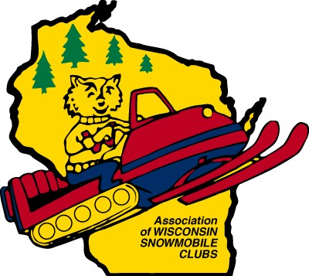

ASSOCIATION OF WISCONSIN SNOWMOBILE CLUBS 2024 SCHOLARSHIP APPLICATION CRITERIA

The Association of Wisconsin Snowmobile Clubs is pleased to offer scholarships to 2024 high school graduating seniors who are actively involved in snowmobiling. Available scholarships this year include:

$2,000 AWSC Scholarship
$1,500 Eric Shaffer Scholarship
$1,000 AWSC Scholarship
$1,000 Liberty Mutual Scholarship
$1,000 Rome Sno Bandits Scholarship
$1,000 J F Brennan Scholarship
$500 KAOS Scholarship
4 $300 Award of Excellence Scholarships from Ken’s Sports
$300 Track Side Scholarship.

Applicants must be an individual member, son, daughter or legal ward of a family, having a current season’s (2023-2024) membership in an AWSC recognized club with two consecutive seasons (2021-2022 & 2022-2023) of prior membership. He or she is further required to have passed the snowmobile safety course. You may download the complete application form the AWSC website (www.awsc.org/About-Us/Scholarships).

Completed Applications must be typed utilizing the AWSC scholarship application and received by the AWSC office, 529 Trail Side Drive, Suite #200, DeForest, WI 53532 by Thursday, January 4th, 2024. The application may be printed and mailed, hand delivered, faxed (608-846-5534) or emailed to stormyh@awsc.org. Emailed applications must be submitted as one (1) complete PDF file document, this includes all pages and transcript. Please note the total pages on the Front Cover Informational Page. Applications not received by the deadline will be disqualified.

A Complete Scholarship Application Includes:

- Front Cover Informational Page (Don’t forget to mark total pages submitted). Be sure to mark 2 year or 4 year degree.

Page 2

- Student Activity Profile and any additional for sheets needed due to space. (These questions are to denote things YOU have done, not your parents). Page 2 of the Scholarship Application.

- Typewritten (450 words or less words for both essay question) answers to the essay questions Page 3 of the Scholarship Application. Please use one-sided, double-spaced pages and include your name & page number on the top of each page with the word count at the end of the essay.

- A letter of recommendation is not required but may be included. (This letter shall only be from a snowmobile club President at the club or county level)

- A copy of your school transcript

ALL INCOMPLETE APPLICATIONS WILL BE DISQUALIFIED!
(Please utilize the “Sample Scholarship” on the AWSC website for help completing the application appropriately.)

All decisions of the AWSC Scholarship committee are final. Winners and non-winners will be notified (via email) by February 7, 2024. Public recognition of our top winners will be made at the AWSC Convention Banquet on Saturday evening, March 23, 2024 at the Osthoff Resort, Elkhart Lake, WI. Scholarships are meant to help in offsetting the cost of furthering your educations. Therefore, upon submission of a copy of your school billing and the Request for Funds form, the actual money will be deposited with your chosen school or enrollment. Please note by submitting an application you are providing the AWSC and it’s affiliates the right to publish your essay(s) in the AWSC magazine if selected as a winner. Any questions or concerns shall be referred to AWSC Scholarship Committee Chair Theresa Braudt by email at theresabraudt@yahoo.com.

Updated: October 27, 2023
Documents/Scholarship/Scholarship Forms/Scholarship Application Criteria

